<https://github.com/in28minutes/MockitoTutorialForBeginners>

**Unit Testing with junit**

1. **Unit test - test for method**

**Src/test/java**

**Right click - junit test case , search for class, package same as class**

<https://github.com/in28minutes/JUnitIn28minutes>

Code to write test case

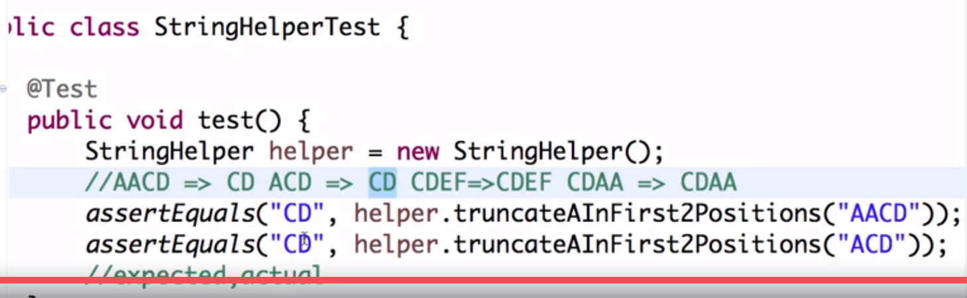

Note: give first value as expected and second as input(or actual)

**Imp Point:** we cannot have return type for test method .

ANY test method should be public and void

1. Method name should be understandable

Note: - if highlight a method and run test case , it will run that method only

assertFalse () ------------expecting false but if it return true condition will fail

assertTrue()

**@Before ,@After**

**@Before :-** it will execute before every test

**@After :-** it will execute after every test

**Requirement :- want to create new instance of helper before every test**

**@BeforeClass , @AfterClass**

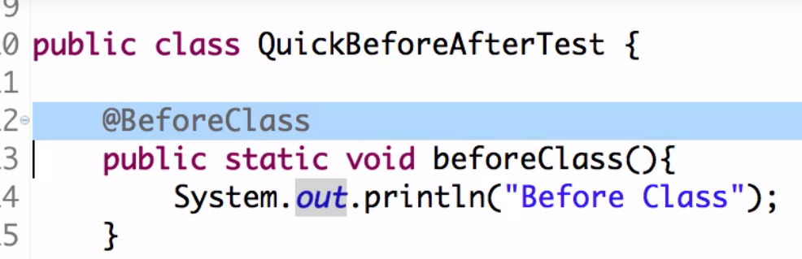

**beforeClass() method should be static and it will execute only once**

**This can probably be use for some data connection**

**Testing exception and arrays**

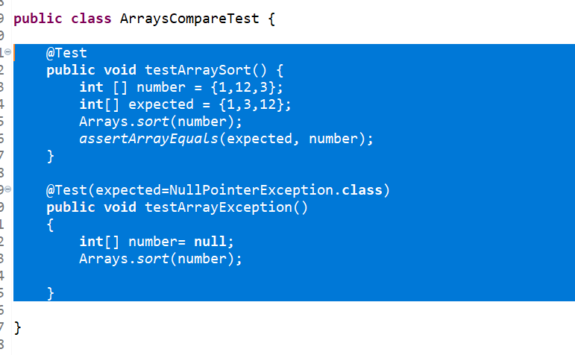

**NOTE: assertArrayEquals use to test array number**

**Testing performance in junit:**

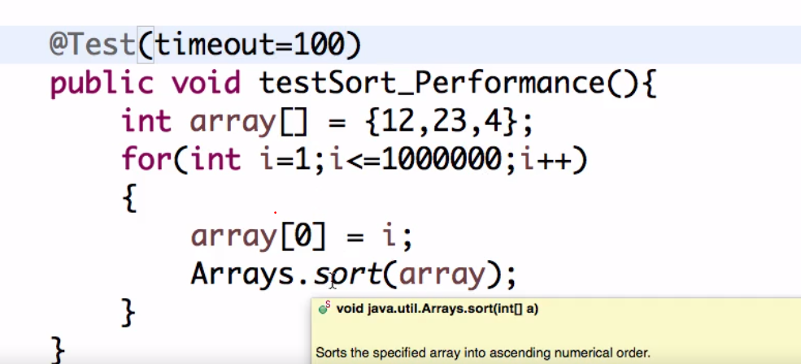

**Parameterized test**

**Same test need to execute for different parameter then use**

Parameterized tests allow a developer to run the same test over and over again using different values

**@RunWith(Parameterized.class)**

**Organize junits into suites**

**Whatever test we want to run at a time create test suites for them**

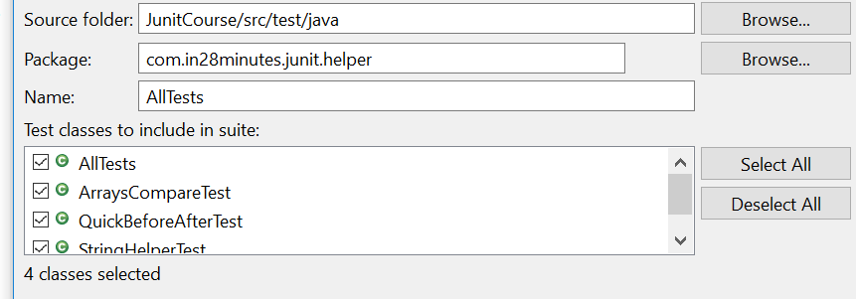

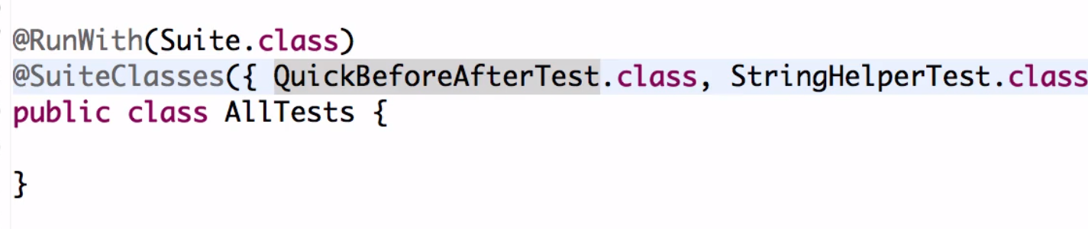

**Unit-2**

**Mockito**

**Github link :**<https://github.com/in28minutes/MockitoTutorialForBeginners>

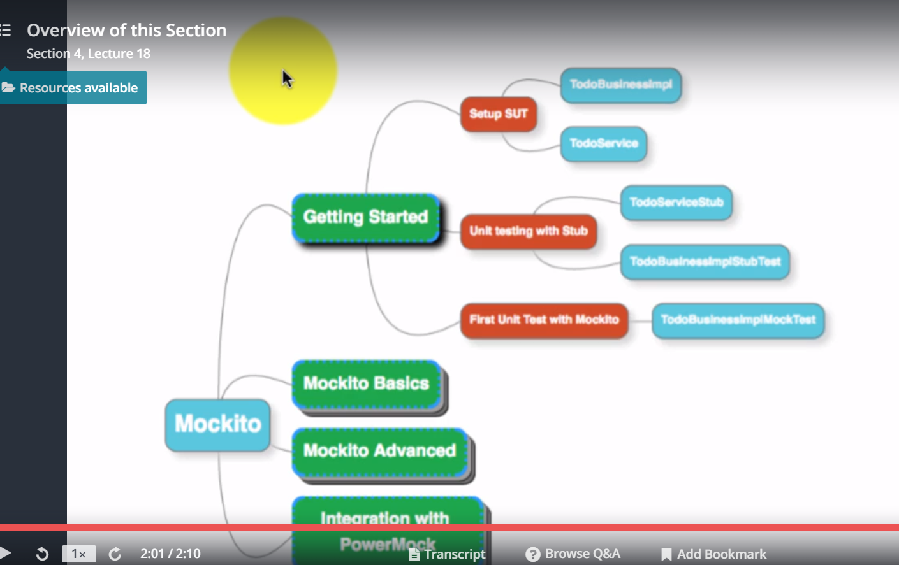

**Step 2:--SUT : system under test**

1)setting up system under test

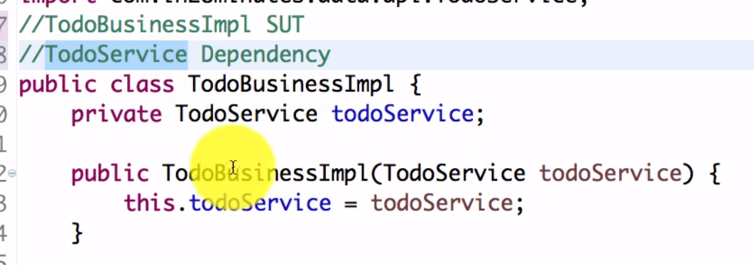

NOTE: we don’t have implementation of todoService . It could be a web service ot it is using by another team which is not develop right now.

**Step 3:---- Stubbing example with disadvantage of stubbing**

We don’t have implementation of TodoService but want to create service so we can do stub.

A stub is nothing but sample implementation of todoService

Note:- a stub is only used for unit testing

a stub is nothing but a class which is use to return some type of dummy data

**2 problem of stub**

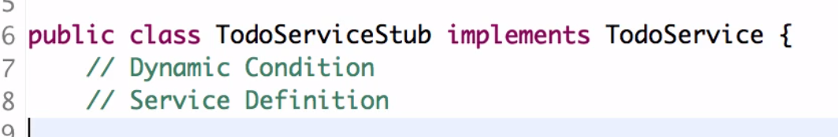

**Step 4:**

**first mockito code**

**We can do mock either class or interface which don’t have implementation**

**Note: mock is the replacement of stub**

**section 5**

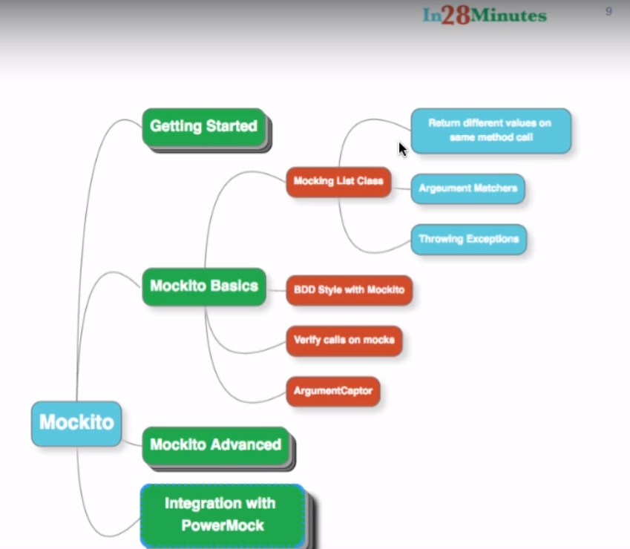

**Step -5:**

**Stubbing variation with mockito: argument matchers and more**

**Dynamically stubbing a method**



**Note in second test case multiple return value is there**

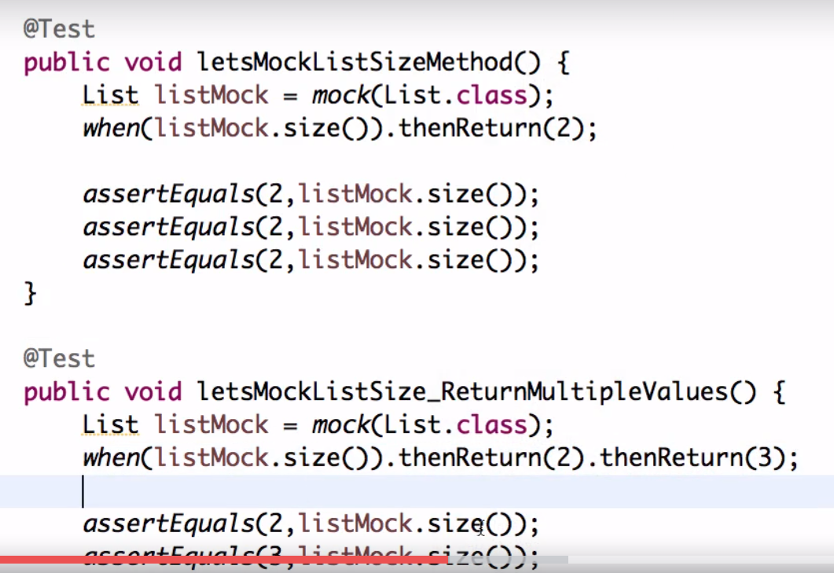

**Note: default null is return of mock**

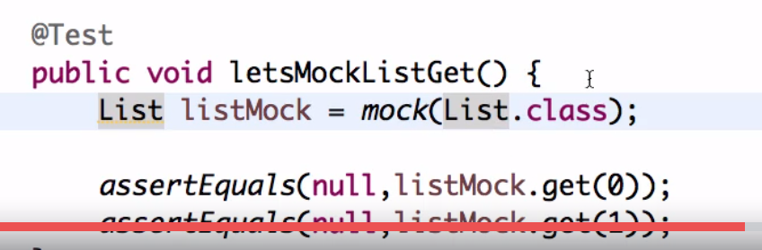

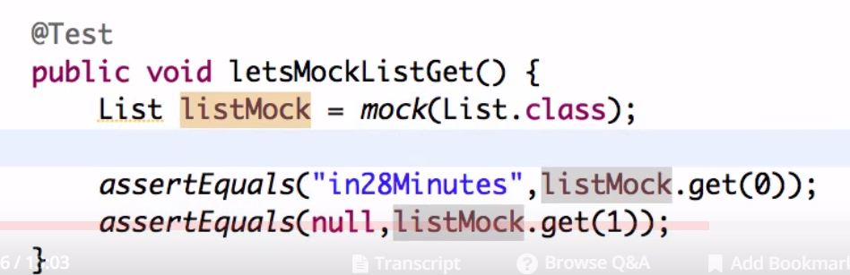

**Note: but in easymock this test case will fail**

**Note: mocking get method**

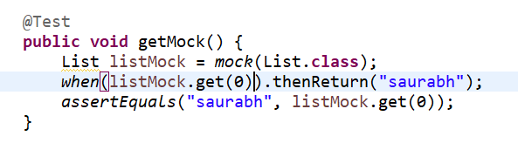

**In this scenario it is valid for 0 only but if want get method is valid for any parameter then concept comes**

**Argument matcher ( and use anyInt())**

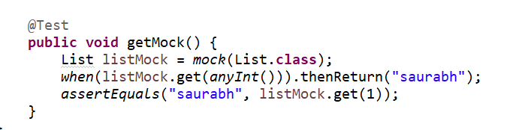

**Throw an exception**

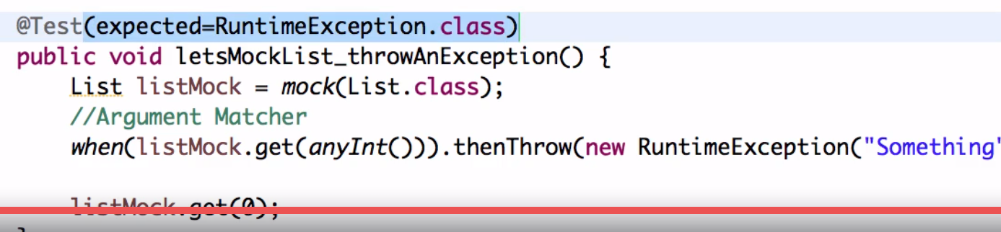

**Step :6 bdd style given**

**Given when then**

**Step 7: verify calls on mock**

**How to check if specific method on mock is call**

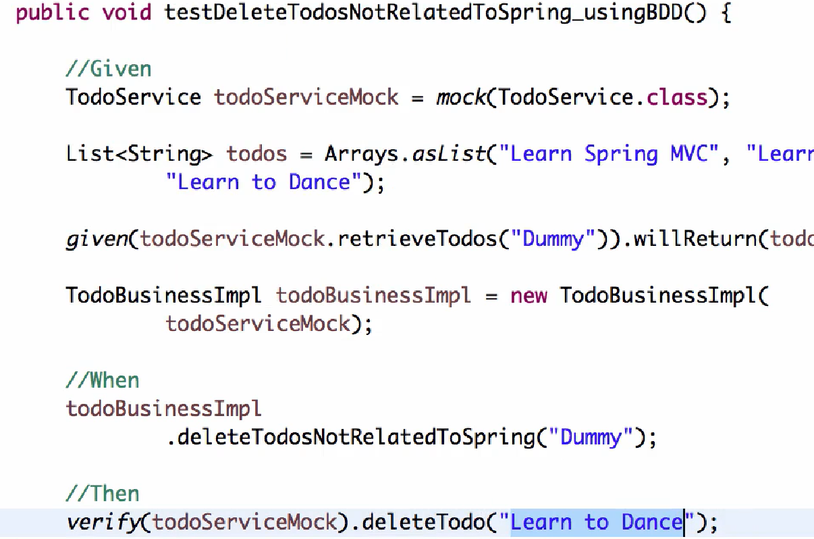

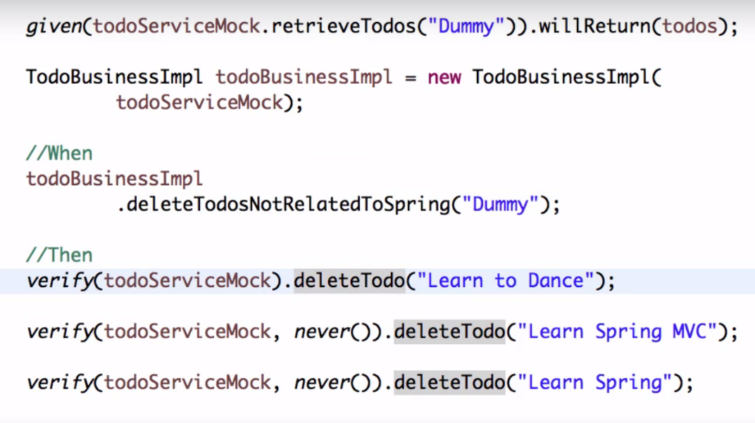

Means on mock object only one times deleteTodo method is called

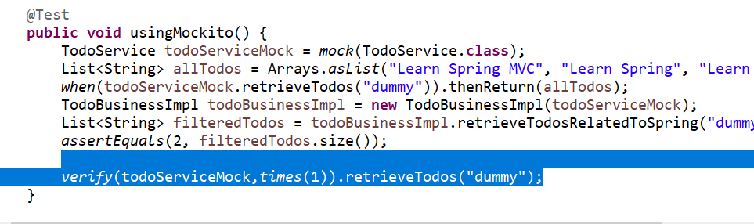

**Step : 8 capturing argument passed to a mock**



**Step 9:**

**Hamcrest matchers :** code is more readable

Allow to write assert statement which is more readable

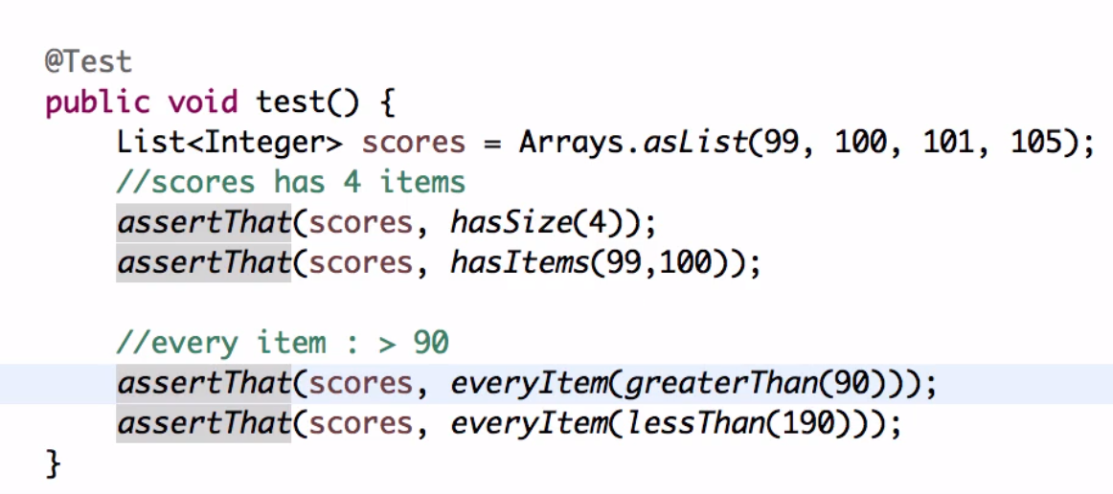

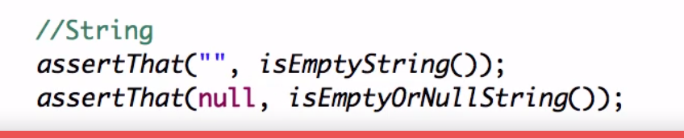

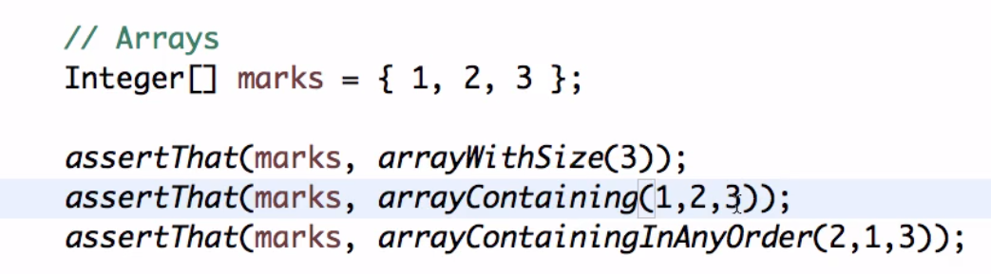

**Step 10:**

**Mockito annotation----@Mock ,@InjectMocks ,@RunWith @Captor**

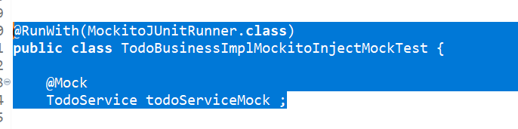

Mock it will make available TodoService class and to run this require mockitojunit runner

**InjectMock**

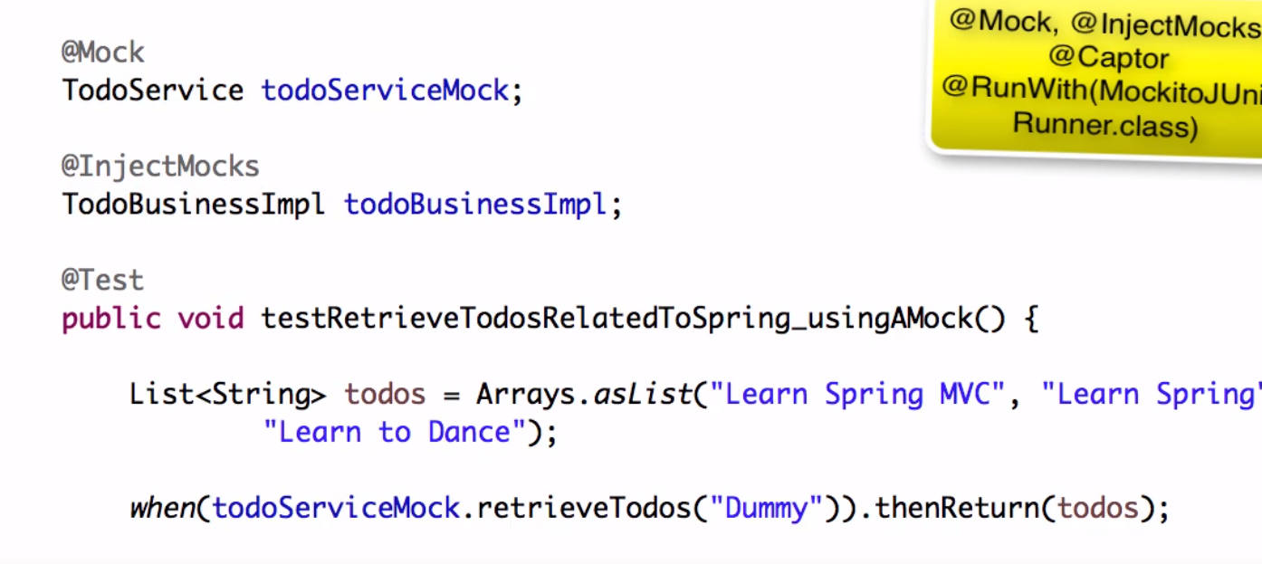

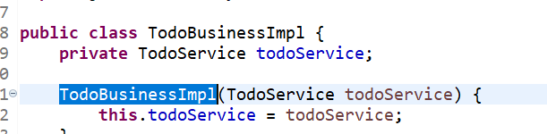

**Note: Here we declare todoBusinessImpl as InjectMocks then junitRunner will check class and all variable any Dependency is there and check that class is declared as mock or not if yes then it will inject automatically no need to use below line**

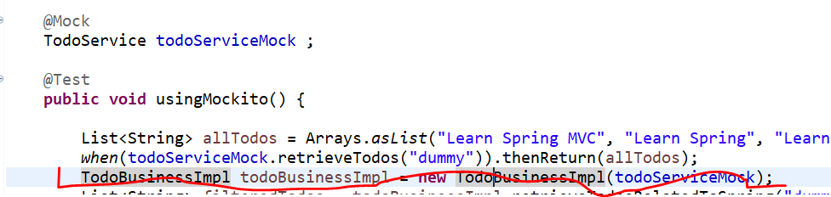

@Mock creates a mock. @InjectMocks creates an instance of the class and injects the mocks that are created with the @Mock (or @Spy) annotations into this instance.

Note that you must use @RunWith(MockitoJUnitRunner.class) or Mockito.initMocks(this) to initialize these mocks and inject them.

<<https://stackoverflow.com/questions/16467685/difference-between-mock-and-injectmocks>>

**Step :11 (mockito junit rule)**

Note: mockitoJunitRunner will check all the mocks are created or not

1. If you want to run 2 junit runner that is not possible

Note we can run only one runner but mulitple rule which run before and after test

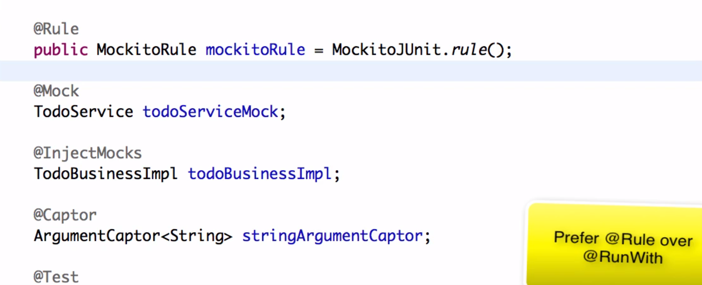

**Step 13: Mockito Spy**

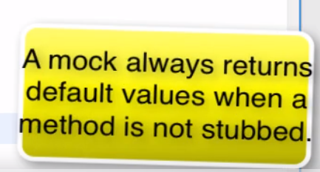

**Note by default mock return default value when we stub it then only it will return some value**

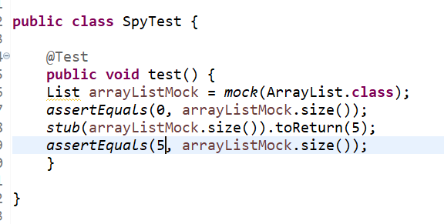

**Mock will not effect original arraylist but if we want change in original arraylist then we will use spy**

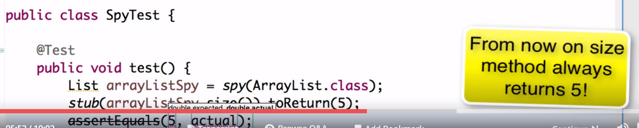

**note we can overwrite method using spy**

 The difference is that in mock, you are creating a complete mock or fake object while in spy, there is the real object and you just spying or stubbing specific methods of it.

When using **mock objects**, the default behavior of the method when not stub is **do nothing**. Simple means, if its a void method, then it will do nothing when you call the method or if its a method with a return then it may return null, empty or the default value.

While in spy objects, of course, since it is a real method, when you are not stubbing the method, then it will call the real method behavior. If you want to change and mock the method, then you need to stub it.

<<https://javapointers.com/tutorial/difference-between-spy-and-mock-in-mockito/>>

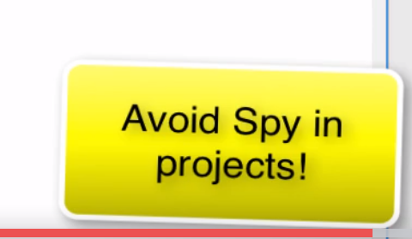

**Step 14**

Why does mockito not allow stubbing final and private method

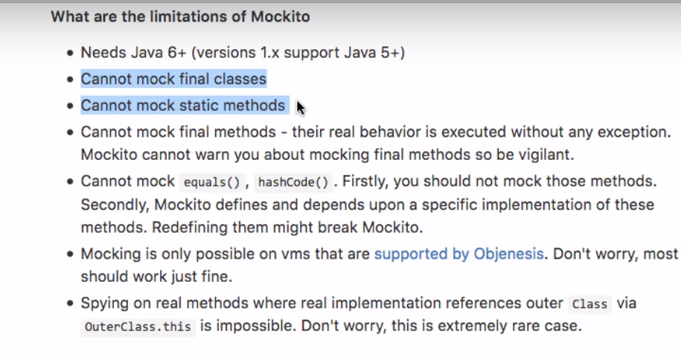

<https://github.com/mockito/mockito/wiki/FAQ>

**Step 15: setting up powermock and system under test**

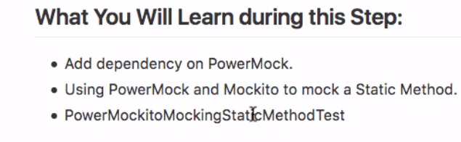

**Integrate power mock with mockito**

**Continue mocking with static method**

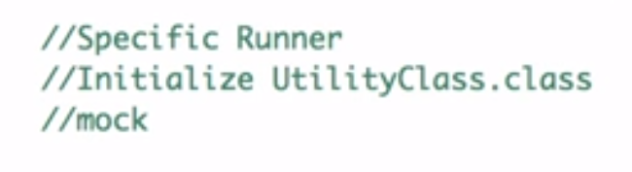

**When we want to use mock with powermock 3 things need to do**

**Then need to define specific runner.**

**1)**



**2)**

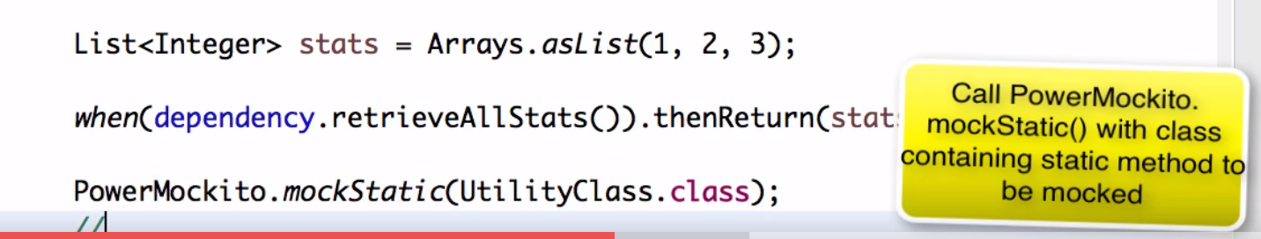

**3)**

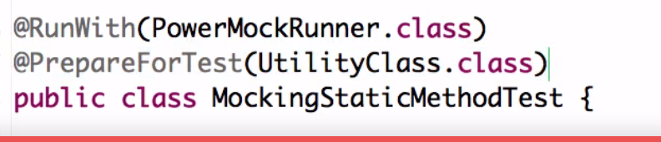

@PrepareforTest need to define( class having static method)

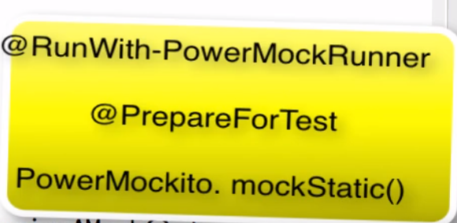

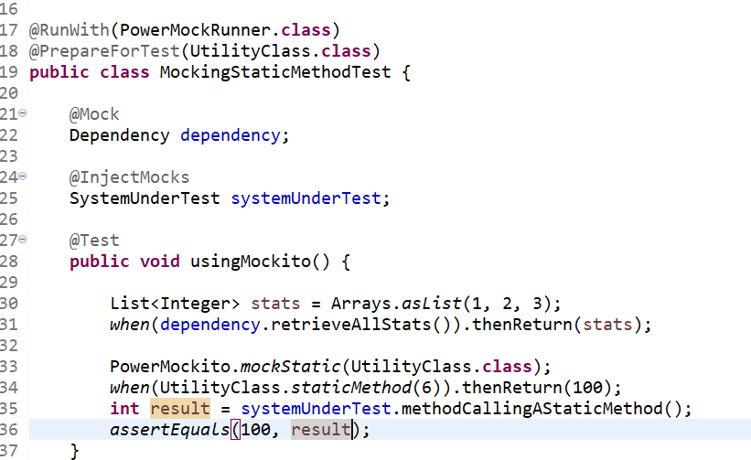

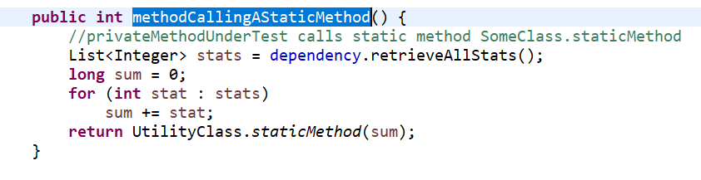

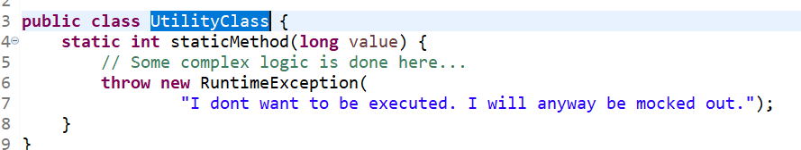

How to check UtilityClass.staticMethod is called or not

Solution this is again 2 step process

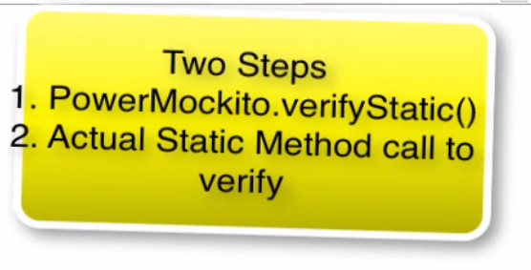

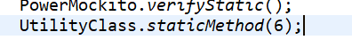

**Step 16: Invoking private method**

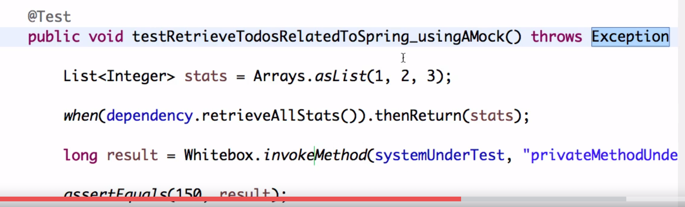

**First argument is instance of a class and second is private method name**

**Step 17: Mocking a constructor**

**2 step**

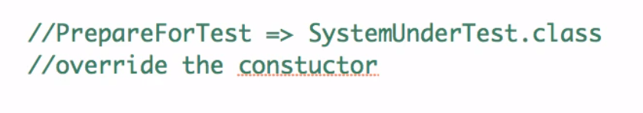

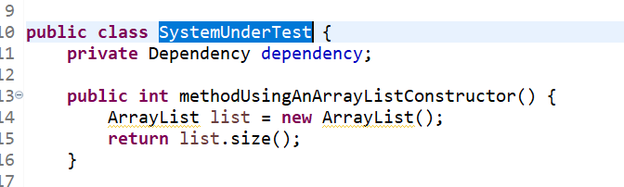

/*To be able to mock the Constructor, we need to add in the Class that creates the new object*/})

